Primary Treatment
3.1. Facility Types
Primary treatment in this design is achieved using circular primary clarifiers. While both circular and rectangular clarifiers are widely used, circular tanks were selected due to their hydraulic efficiency, ease of sludge removal, and suitability for continuous operation in medium-to-large wastewater treatment plants. Circular clarifiers promote uniform radial flow distribution, reducing dead zones and short-circuiting, which enhances sedimentation performance. Mechanically, the rotating sludge scraper arms in circular clarifiers allow for reliable and consistent solids removal with minimal manual intervention. Moreover, for a greenfield development with expected long-term service and increasing population, circular clarifiers provide a scalable, space-efficient, and operationally robust solution.

3.2. Design Description

Dfdsfsd

3.3. Pollutants

The removal efficiency for BOD and suspended soils (TSS) was determined based on the influent BOD5 concentration (370 mg/L) and the detention time required, having into account that lower temperatures affect directly the particles settlement velocity due to changes in the viscosity of the water (Metcalf & Eddy I AECOM, 2014). Likewise, the author mentions that the removal efficiency for BOD moves into the interval of 25 to 40 percent, for TSS is between 50 to 70 percent. The author presents the relationship between removal efficiency and detention time (Equation X), it is given by empirical constants at 20°C for BOD and TSS (Table X).
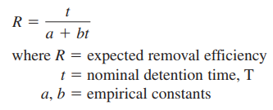
Equation X.
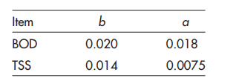
Table X. Empirical constants for removal efficiency of BOD and TSS.

The detention time (t) was determined by practicing several iterations that meets the efficiency requirements into this primary treatment stage and pointing to meet the efficiency requirements for the secondary treatments stage. To meet such requirements, the target of BOD removal efficiency was set in 30%. Further, the detention time (t) was adjusted using a security factor defined by the temperature conditions prevailing in the operation place. Metcalf & Eddy (2014) presents a curve to estimate such security factor needed to increase the detention time for temperatures lower than 20°C (Figure X).
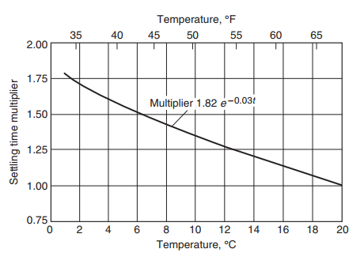
Figure X. Curve of increase in detention time required at lower temperatures, to achieve the same sedimentation performance in clarifiers at 20°C.

To meet all requirements for this stage of the primary treatment design it is necessary to evaluate the adjusted detention time is between the time interval of 1.5 hours and 2.5 hours. Below is presented the summary of the removal efficiency for BOD and TSS, and the adjusted detention time calculated.

Removal Efficiency for adjusted detention time of peak flow rate (t_PHR) at 10°C
Adjusted detention time (t_PHR) = 1.82h
R_BOD = 30.0% -> 25% < R_BOD < 40%
R_TSS = 51.14% -> 50% < R_TSS < 70%

Removal Efficiency for detention time of average dry weather flow (t_ADW) at 10°C
Detention time (t_ADW) = 2.50h
R_BOD = 33.66% -> 25% < R_BOD < 40%
R_TSS = 55.42% -> 50% < R_TSS < 70%

As was mentioned before, the removal efficiency must be calculated at 20°C temperature conditions. It means that the detention times presented above must be corrected dividing each one by the security factor corresponding to the temperature of 10°C. Finally, the greater BOD5 concentration at the end of the primary treatment is 259 mg/L. This BOD5 concentration will be treated during the secondary treatment.

Note

Protection against failure

Reference
[Metcalf and Eddy, 2014] Metcalf & Eddy I AECOM. (2014). Wastewater engineering : treatment and resource recovery (5th ed.). McGraw-Hill Education.

